Title

SOP for VPN Client Installation

Prepared By
Helpdesk

Date: Monday, July 19, 2010

Version 1.0

Document History

Date | Author | Revision | Description
26-10-2010 | MN Kalyan | 1.0 | Document Creation

Approved By: | Tata Business Support Services Limited
Rama Krishna TV | 1.0 | Manager-Technology

Distribution List
Name | Department | Company | Rights
MN Kalyan | Technology | Tata BSS | Review & Comment
Ramakrishna TV | Technology | Tata BSS | Modify
Ali Hyder | Technology | Tata BSS | Review & Approve

Security Classification: Tata BSS Restricted.

VPN Client Installation
Steps:-

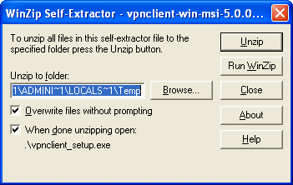
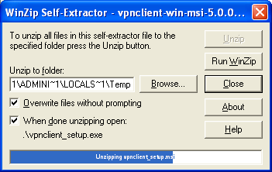

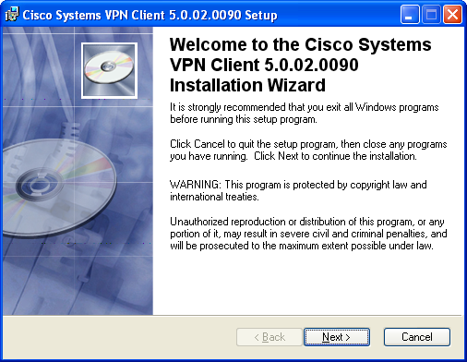
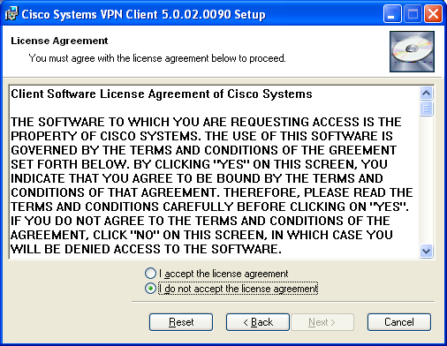
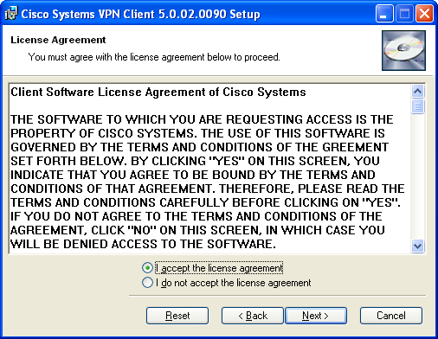
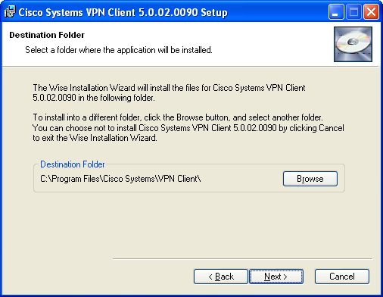
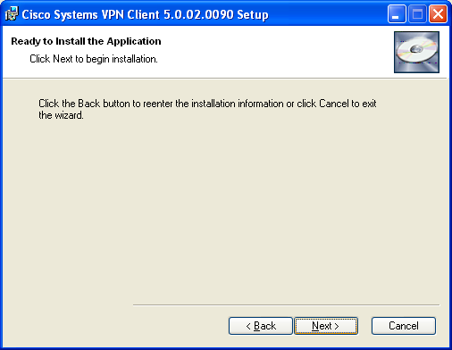
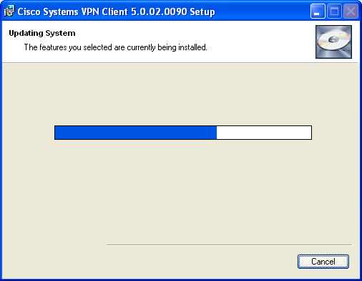
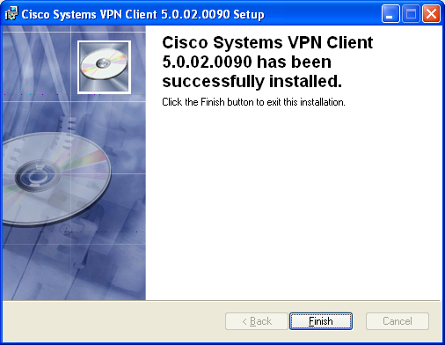

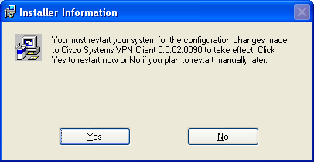
After Completion of Installation please follow the below mentioned step:-
1) Copy SerWizSol-HYD VPN .pcf file and paste the below mentioned path.
C:\Program Files\Cisco Systems\VPN Client\Profiles

